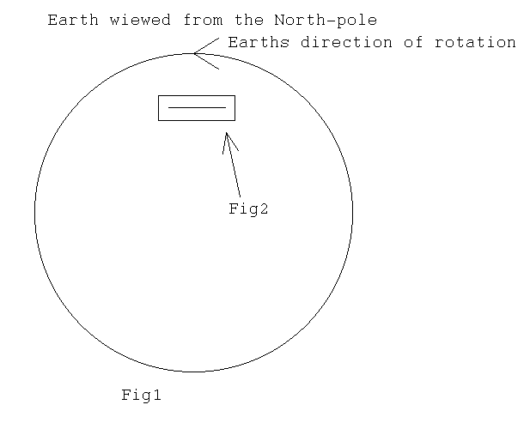
About magnetic fields of Earth and other heavenly bodies.

When we observe Earths rotation at the atomic level,from the point of special relativity,we observe,that in highly small distance of time,when movement of rotation can be observed as streight movement,(like Einstein did in His samples),Earths particles experience Lorentz-contraction,which is greater,closer earth-surfice we get.

When this is applyed to movements of electrons of the atom,other movements,than which Lorentz-contraction applyes,can be ignored,because movement to these directions doesn´t chance.

When We observe effects of contraction to movement of electrons toward it and opposite to it,We notice following.(Fig2)

If We observe line between Earths poles ja points of Earth ,which have constant distance and We think velocities of electrons at that point,We discover accordin to figure 2,that relativly to Earths surfice,electrons move in different velocity in opposite directions (caust by Earths rotation according special theory of relativity).

If We now consider magnetic field caust by these electrons,has electron moving to opposite direction than Earth bigger magnetic field caust by electrons bigger velocity.

Total magnetic field in this point is equal to that,which would be born,if electron would move in speed,which is difference between opposite direction electrons.

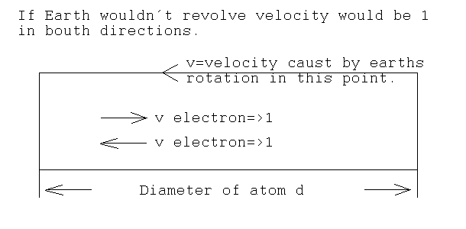
Fig2

Closer Earths center We get,smaller is diversion of velocities and smaller is borning magnetic field/atom.

As a summ of these magnetic fields borns magnetic field of heavenly bodies,like Earth,so it it would seem like Nobelist Blackett was right,when he asummed,that magnetic fields of heavenly bodies was caust by their rotation.

This explanes,why Earth can be ”magnett”,even when temperature of the Earths core is over Curies point.There is no need for ferromagnetic center,which would,cause magnetic field,purpose for Earths center is to magnify magnetic fiel,like giant ”ironheart” in electrical transformer.

Because ”ironheard” isn´t symmetrical,in it´s form or it´s materia,magnetic poles aren´t equal to geographical poles.I´m also ware of the fact,that Earth can´t be handeled like a rigid body,but the calculations I´w got from this theory are equal to measurements of Earths magnetic field.

Also there are facts,that Earth has reversed is magnetic polarity,which can be explaned whit the asumption,that Earths position againgst gravitional field has changed,because thats My conclution,magnetic field of heavenly body,is caust from bodys rotation in relation to gravitional field effecting it.

I´m well avered,that this days Earths magnetic field is assummed to be formed from the inner movement of Earths insides or inside matters spins and I´m also avered,that x-ray radiator like scorpius X-1 has magnetic field perpendicular against it´s rotating axel,like sun doesn´t have magnetic south-pole.

I belive,that observations I´w told above,have been caust by something that We hasn´t not yet been able to detect.

I trust that My theory has at least a bit of thrut,because,it relies on calculations,that are very simple and has relatided to special theory of relativity.

